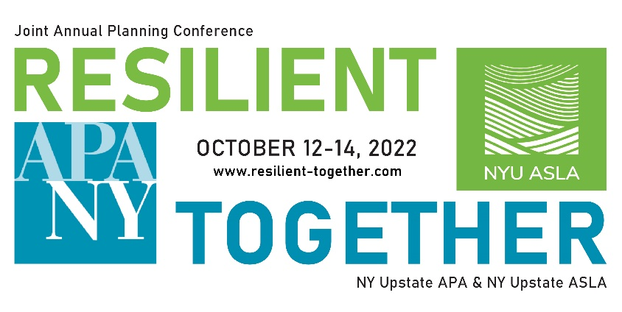

2022 Joint Conference Registration Remittance Form

Purchaser Information

Registration Type:
Firm/Organization:
Name:
Address:
City/State/Zip:
Phone:
Email:
Amount:

Make checks payable to: Send payment & remittance form to:
Western New York Section APA ATTN: Sarah Gatti
Erie County
Dept. of Environment and Planning
95 Franklin Street, Tenth Floor
Buffalo, NY 14202

Receipt Section – to be filled out by WNY APA

Amount Paid:
Payment Method:
Check # (if applicable):

As Treasurer of the Western New York Section of the American Planning Association, I confirm that the above business/organization has paid the amount shown for the 2022 Joint Conference.

Date:
Sarah Gatti, WNY APA Treasurer

